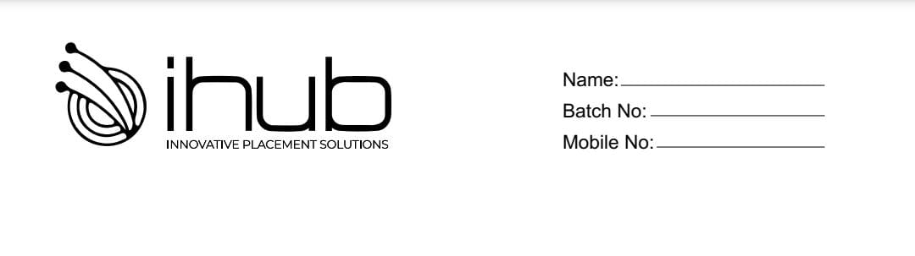

**Mock Test**

**MCQ**

**1) What is the return type of the hashCode () method in the Object class?**

a) Object

b) int

c) long

d) void

**2) Which of the following is true about the anonymous inner class?**

a) It has only methods

b) Objects can't be created

c) It has a fixed class name

d) It has no class name

**3) What is the use of the intern () method?**

a) It returns the existing string from memory

b) It creates a new string in the database

c) It modifies the existing string in the database

d) None of the above

**4)What will be the output of the following program?**

public class Test2 {

   public static void main (String[] args) {

    StringBuffer s1 = new StringBuffer("Complete");

    s1.setCharAt(1,'i');

 s1.setCharAt(7,'d');

         System.out.println(s1);

 }

 }

a) Complete

b) Iomplede

c) Cimpletd

d) Coipletd

**5) Which of the following is a valid syntax to synchronize the HashMap?**

a) Map m = hashMap.synchronizeMap();

b) HashMap map =hashMap.synchronizeMap();

c) Map m1 = Collections.synchronizedMap(hashMap);

d) Map m2 = Collection.synchronizeMap(hashMap);

**6) What is not the use of “this” keyword in Java?**  
a) Referring to the instance variable when a local variable has the same name  
b) Passing itself to the method of the same class  
c) Passing itself to another method  
d) Calling another constructor in constructor chaining

**7) What is Truncation in Java?**a) Floating-point value assigned to a Floating type  
b) Floating-point value assigned to an integer type  
c) Integer value assigned to floating type  
d) Integer value assigned to floating type

**8)** **Which exception is thrown when java is out of memory?**a) MemoryErrorb) OutOfMemoryError  
c) MemoryOutOfBoundsException  
d) MemoryFullException

**9) Which of these statements is incorrect about Thread?**a) start() method is used to begin execution of the thread  
b) run() method is used to begin execution of a thread before start() method in special cases  
c) A thread can be formed by implementing Runnable interface only  
d) A thread can be formed by a class that extends Thread class

**10)** **Which of these class is superclass of String and StringBuffer class?**a) java.util  
b) java.lang  
c) ArrayList  
d) None of the mentioned

**11)** **Which of this method of class String is used to obtain a length of String object?**  
a) get()  
b) Sizeof()  
c) lengthof()  
d) length()

**12)** **Which of these constructors is used to create an empty String object?**a) String()  
b) String(void)  
c) String(0)  
d) None of the mentioned

**13**) **Which of these is an incorrect statement?**  
a) String objects are immutable, they cannot be changed  
b) String object can point to some other reference of String variable  
c) StringBuffer class is used to store string in a buffer for later use  
d) None of the mentioned

**14)** **Which of the following keywords is used for throwing exception manually?**  
a) finally  
b) try  
c) throw  
d) catch

**15) Which of the following classes can catch all exceptions which cannot be caught?**a) RuntimeException  
b) Error  
c) Exception  
d) ParentException

**16) Which of the following is a super class of all exception type classes?**  
a) Catchable  
b) RuntimeExceptions  
c) String  
d) Throwable

**17) Which of the following keyword is used by a calling function to handle exception thrown by a called function?**a) throws  
b) throw  
c) try  
d) catch

**18) Which of the following handles the exception when a catch is not used?**  
a) finally  
b) throw handler  
c) default handler  
d) java run time system

**19)** **Which of the following should be true of the object thrown by a thrown statement?**a) Should be assignable to String type  
b) Should be assignable to Exception type  
c) Should be assignable to Throwable type  
d) Should be assignable to Error type

**20) At runtime, error is recoverable.**  
a) True  
b) False

**Programming Questions**

1. **Write a java program to remove special characters from given string?**

Input: he@l#l_o$

Output: Hello

1. **Write a java program to display reverse of each word in a sentence?**

Input: This is java class

Output: sihT si avaj sslac

1. **Write a java program to check given string is anagram or not?**

Input:

silent

listen

Output:

It is Anagram string

1. **Write a java program to display the string in a given format?**

Input: A1B2C3D4

Output: ABBCCCDDDD

1. **Write a java program to display the string in a given format?**

Input:

XYZ

Output:

XY

XZ

YX

YZ

ZX

ZY

1. **Write a java program to display the string starting with uppercase letters?**

Input: This is Java class For students

Output: This Java For

1. **Write a java program to display number of words present in String?**

Input: This is is java java class

Output: This=1, is=2, java=2, class=1

1. **Write a java program to display number of characters present in string?**

input: java

output: j=1,a=2,v=1

1. **Write a java program to display distinct and unique elements from given array?**

Input:

4 7 1 2 7 9 6 6 4 8

Output:

Unique elements : 4 7 1 2 9 6 8

Duplicate elements : 4 7 6

1. **Write a java program to display distinct elements from positive integer array?**

Input:

**1 2 2 3 3 3 4 4 4 4**

Output:

**1 2 3 4**

1. **Write a java program to display leader elements from given array?**

input:

4 6 64 7 12 5 9

output:

9 12 64

1. **Write a java program to find out missing element from given array?**

Input:

5 6 2 3 1

Output:

4

1. **Write a java program to delete first occurrence of a given element?**

Input:

arr = 6 4 2 3 9 2 7 2 1

element = 2

Output:

6 4 3 9 2 7 2 1

1. **Write a java program to check number of uppercase letters, lowercase letters, digits and special symbols?**

Input:

This Is Java Class32

Output:

Uppercase letters: 4

Lowercase letters: 11

Digits: 2

Words: 4

Spaces: 3

1. **Write a java program to display 10 Fibonacci numbers?**

output: 0 1 1 2 3 5 8 13 21 34

1. **Write a java program to identify and print all elements in an array that are greater than both their immediate predecessors and successors, considering the first and last elements as having only one neighbor?**

Input:

1 3 20 4 75 0 90

Output:

20 75 90

1. **Write a java program to determine the smallest number of coins needed to total 86 rupees. Use the denominations provided in the array {1,2,5,10}?**

Output:

1 coin(s) of 1 rupee(s)

1 coin(s) of 5 rupee(s)

8 coin(s) of 10 rupee(s)

1. **Write a java program to display largest prime number in the list?**

Input:

2 3 4 5 7 9 11 12

Output:

11

1. **Write a java program to count number of even and odd elements from given array?**

Input:

3 4 7 9 2 6 1

Output:

Even elements : 3

Odd elements : 4

1. **Write a java program to display least element from given array?**

Input:

7 2 4 9 1 6 3

Output: 1